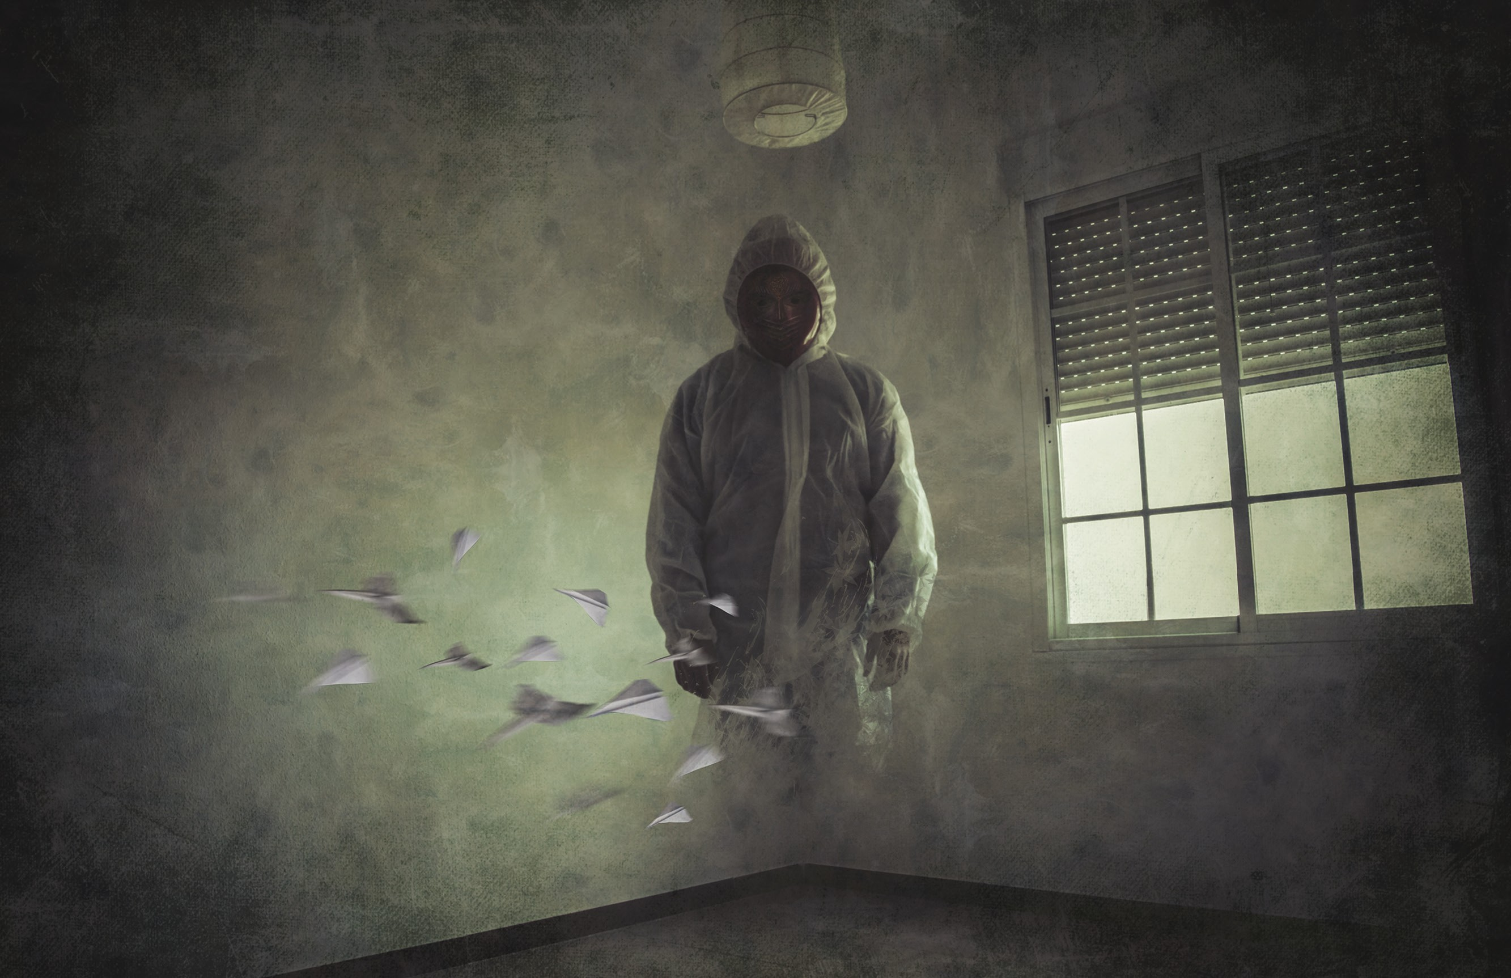

YOUR BOOK TITLE GOES HERE
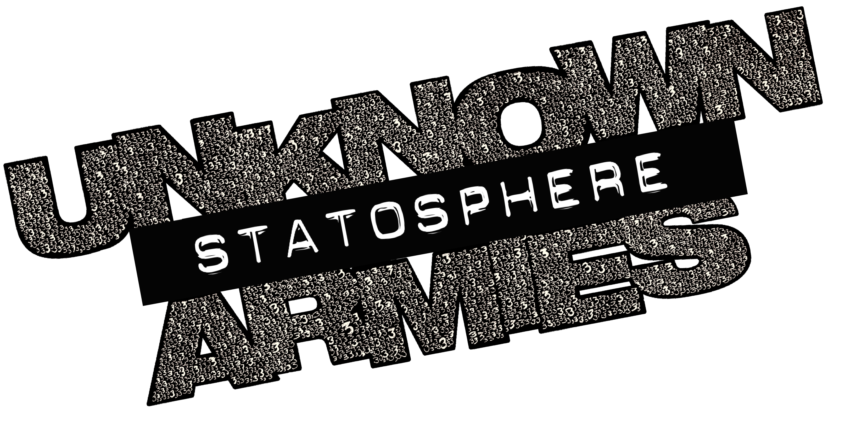
YOUR OWN PHOTO IMAGE GOES ABOVE

CHAPTER HEADING
page reference margin notes

HEADING 1

HEADING 2

HEADING 3
body following header
body text
Embedded header: text after the colon is normal color

ALSO, THIS PAGE USES THE FULL PAGE LAYOUT. IT IS FOR FULL PAGE TEXT WITH ART AND NO OR VERY BRIEF MARGIN NOTES.

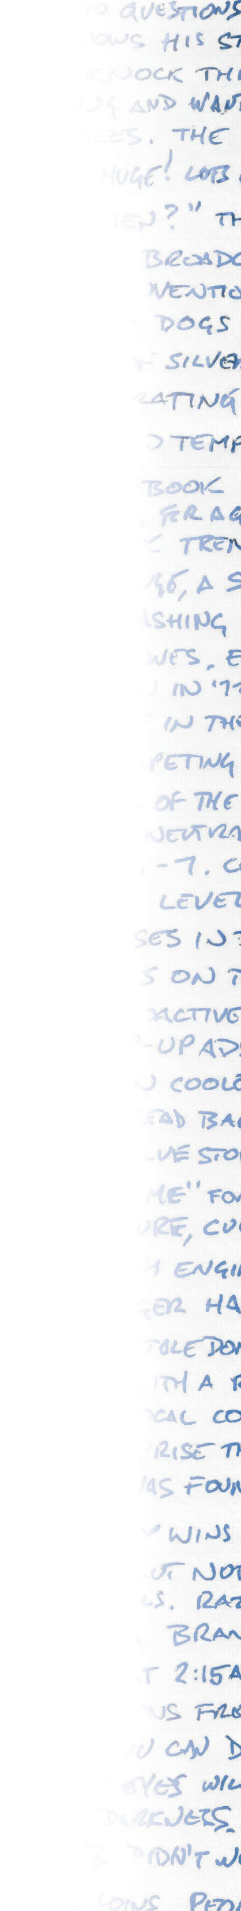

A SIDEBAR HEADER
Sidebars in the Unknown Armies books have swipe flourishes above and below them but Statosphere community content sidebars are just squares.

A SIDEBAR SUBHEADER
It’s a good idea not to make sidebars too big. If they get too big they should probably just be in the body text with a proper section and standard headers.

You can also put examples into sidebars, like this.

Example text is paragraph style with a fill behind it so that it looks like it is in a box but doesn’t need a frame of its own

2

THIS IS AN EXAMPLE OF A WIDE MARGIN PAGE
It has been designed to allow wide margin notes.
These aren’t margin notes, these are Tynes notes, or writin weir tins in te marin.
These look best on the

Don’t forget: images should always be photographic and not line art. Images should extend to the bleed of the page but do not extend past the line over to the right.

Unless they are full page splash images in which case go to all edges.

Use two columns. You don’t need to include the decorative margin art frames, however.

When in doubt for typefaces, use a sans serif for body and header. If you don’t have Dax, there are several cheap or free alternatives that should fit the bill.

Every Unknown Armies book has its own color. Book One is Blue, Book Two is Red, Book Three is Purple.
Statosphere content is a kind of Rust Orange. The CMYK is 15/50/85/50.
The lighter version (as seen in table shading, and for the boxes behind example text) is 2/8/13/8.

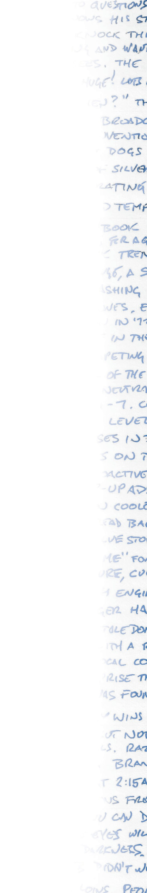
The Statosphere is for fan-made releases of Unknown Armies 3rd edition content, published under a special license and released exclusively through OneBookShelf and their community creator programs.

Unknown Armies created by Greg Stolze and John Tynes

Writing and design: XX
Editing and development: XX
Unknown Armies graphic design: Thomas Deeny
Art: XX

This product was created under license. Unknown Armies is a trademark of Greg Stolze and John Tynes, used under license by Trident, Inc., d/b/a Atlas Games.

This work contains material that is copyright © 2017 Atlas Games and/or other authors. Such material is used with permission under the Community Content Agreement for the Statosphere UACC.

All other original material in this work is copyright © [2017] by [your legal name or company name] and published under the Community Content Agreement for the Statosphere UACC.

